Distance
Speed
Time
Guinness World Records

For each Guinness World Records below, calculate
the speed of the record in metres per second.

Record | Speed
Agris Kazelniks covered a distance of 20m carrying 300kg on his shoulders in a time of 11.4 seconds. | 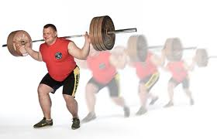
Georges Christen set the record for the fastest 10m carrying a table with a weight on it in the mouth at 6.6 seconds. | 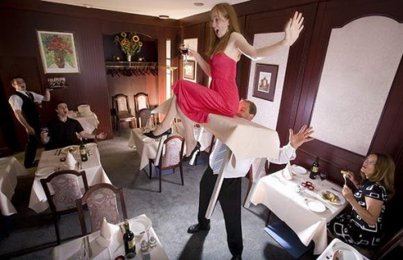
Tillman the English Bulldog covered a 100m stretch of carpark in a time of 19.7 seconds. | 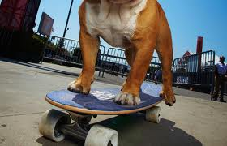
The fastest 100 metre hurdles wearing flippers is 14.8 seconds and was achieved by Christopher Irmscher in 2008. | 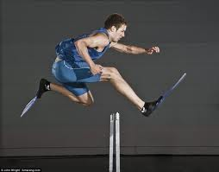
The fastest 100m with a can balanced on head by a dog is 2 min 55 sec achieved by Sweet Pea, an Australian Shepherd/Border Collie cross. | 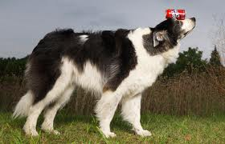
The fastest time to run a half marathon (21km) whilst pushing a pram is 1hr 30 min by Nancy Schubring. (Hint: You will need to change km to m and the time to seconds first) | 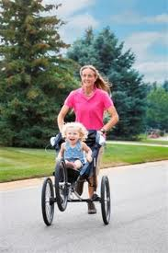

Ashrita Furman is the record holder for the most number of records held at the same time by an individual. Some of his current Guinness World Records are shown below. Calculate the speed of each of his records in the units shown in the box. 1 mile is equal to 1600 metres.

Record | Speed
The fastest time to travel 100m on a space hopper at 30.2 sec. | (in m/s)
The fastest mile carrying a person on his shoulders at 15 min 11 sec. | (in m/s)
The fastest 1 mile sack race at 16 min 41 sec. | (in m/s)
The fastest time to run a mile while balancing a baseball bat on a finger at 7 min 5 sec. | (in m/s)
The fastest piggy back race over 1 mile at 12 min 47 sec. | (in m/s)
The fastest mile hopping on a pogo stick whilst juggling three balls at 23 min 28 sec. | (in m/s)
The fastest mile covered on spring loaded stilts at 7 min 13 sec. | (in m/s)
The fastest time to hula hoop 10km at 1hr 25 min. | (in km/min)

The fastest toilet is the “Bog Standard”, a motorcycle and sidecar hidden under a bathroom set, consisting of a bathtub, sink and laundry basket. The record was set by Edd China and can travel at a speed of 68 km/h.
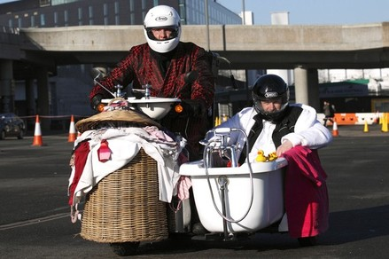
How far could the toilet travel in 40 minutes?

How long will it take for the toilet to travel 300km?

